Name: _____________________ Period: _____

THE MEN WHO BUILT AMERICA:
Video Questions
(If you miss an episode in class then look it up on YouTube and watch it there)

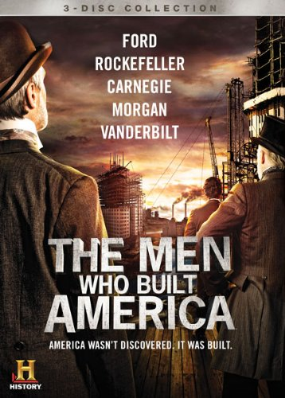
- What nickname does Cornelius Vanderbilt acquire and how does he acquire it? (First 5 minutes)

- What risk does Vanderbilt take at the height of his shipping career just before the Civil War?

- How does Vanderbilt acquire nearly half of all the railroads across America? (You’ll have to summarize the first 20 min of the video so pay attention!)

- What big project (the biggest urban project in America up to that time) does Vanderbilt create in New York City?

- Why did Vanderbilt want control of the Erie Rail Line and how did he attempt to get it?

- What do Jay Gould and Jim Fisk do to thwart Vanderbilt’s plan to buy the Erie Rail Line?

- Sumner Redstone (majority owner of Viacom & CBS) claims that a successful business owner objective should be what? (Hint: it’s not about how much money a business owner makes)

- What does Vanderbilt decide that he needs to do to finally control a majority of the railroads in America?

- Who does Vanderbilt invite from Cleveland to New York to move his plan forward?

- What event changes the outlook of the man from Cleveland?

Episode 2: Oil Strike______________________________________________________________________________________
- In your opinion, who comes out with the better deal between Vanderbilt and Rockefeller and Why?(You may not be able to immediately answer this question until later in the video)

- Why did Rockefeller have to learn to work so hard?

- What does Rockefeller promise Vanderbilt that he may not be able to keep?

- According to Donald Trump (Real Estate Mogul and Nick Hartman’s hero) besides being smart and having vision, what trait does the most successful people in life exhibit?

- Why do Americans fear kerosene and how does Rockefeller calm those fears?

- What does Rockefeller do with all of the profit he will make by playing the railroads against each other and what do we call it today?

- What does Vanderbilt do to regain an advantage over Rockefeller?

- How does Rockefeller react to Vanderbilt’s move? (How does he perceive it?)

- What does Rockefeller do to counter Vanderbilt’s move against him?

- What is the ultimate result of Rockefeller’s move against Vanderbilt and the railroads?

- After Vanderbilt dies (of old age), who becomes Rockefeller’s new competition?

- What does Rockefeller’s new competition do that makes Rockefeller mad?

- What does Rockefeller do in return?

- Who wins between Rockefeller and his new competition?

- Who loses (besides the one man Rockefeller was competing against)?

- What was Andrew Carnegie’s background (his life as a young man and as he grows into an adult)?

- What does Scott want Carnegie to do to launch Scott’s railroad?

- What obstacle does Carnegie run into and what substance allows Carnegie to solve the problem?
- What is the problem with this new substance?

- What does Henry Bessemer provide to solve Carnegie’s problem with the new substance?

- After solving the problem of how to build the bridge, what new problem does Carnegie encounter?

- According to Carly Fiorina (Former CEO of Hewlett-Packard), what do successful people learn to overcome?

- After the bridge is built, what does Carnegie do to convince the public that the bridge is safe?

- What does Carnegie build after he builds the bridge?

Episode 4: Blood is Spilled__________________________________________________________________________________________________________________
- Why does Carnegie want revenge on Rockefeller?

- When the railroads aren’t building new lines any longer, where does Carnegie turn to sell steel?

- What allows cities to stop expanding outward and to start expanding upward?

- What is Carnegie’s plan to be the most profitable?

- Who is Henry Frick and what does he provide for Carnegie?

- What is Frick trying to prove?

- Why does Frick lower the dam holding back the water over Johnstown?

- Why does the Johnstown telegraph office ignore the warning that the damn could break and what does this teach us about ignoring warnings even after false warnings have been given?

- What does Carnegie do to make up for the Johnstown flood?

- Who has a bigger presence than Carnegie at Carnegie Hall?

- What do Rockefeller and Carnegie do for each other as part of their rivalry?

- Why does Carnegie move to Scotland?

- How does Frick run the steel mill?

- What do the employees of the steel mill want?

- How does Frick respond to what the workers want?

- After an employee dies, what does Frick do?

- What do the employees do?

- Who does Frick call in and what do they do?

- What ultimately happens to Frick?

